**CANCER SURVIVAL DATA ANALYSIS**

Name: Afshan Zeba Niyas

Batch name: Data Science(with R)

Project name: Predicting Cancer Treatment Response

Date: 26/02/2024

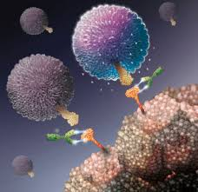

**Objective:**

Conduct survival analysis to investigate the factors influencing the survival time of cancer patients. This project aims to understand the impact of various clinical and demographic variables on patient survival and to identify prognostic factors associated with better or worse outcomes.

**INTRODUCTION**

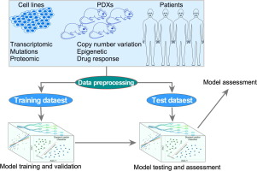

In the realm of oncology research, understanding the factors influencing cancer survival outcomes is crucial for improving patient care and treatment strategies. Survival analysis techniques provide valuable insights into patient prognosis, but analysing large datasets can be complex and daunting. Simple Random Sampling (SRS) offers a streamlined approach to sample selection, enabling researchers to efficiently explore cancer survival data.

In this project, we harness the power of SRS within the Shiny framework to conduct survival analysis on cancer datasets. Shiny, an R package, facilitates the creation of interactive web applications, allowing users to explore data dynamically and visualize results in real-time. By integrating SRS with Shiny, we aim to provide researchers with a user-friendly platform to analyse cancer survival data, identify prognostic factors, and generate actionable insights.

Through this project, we bridge the gap between statistical methodology and user-friendly interface design, empowering researchers to conduct robust survival analysis without the need for advanced programming skills. By leveraging SRS and Shiny, we democratize access to sophisticated analytical techniques, fostering a more inclusive and collaborative approach to cancer research and improving outcomes for cancer patients.

**STEPS**

Steps to implement predictive survival analysis of cancer survivors using R, machine learning, and Shiny:

1. **Data Collection and Preparation**:

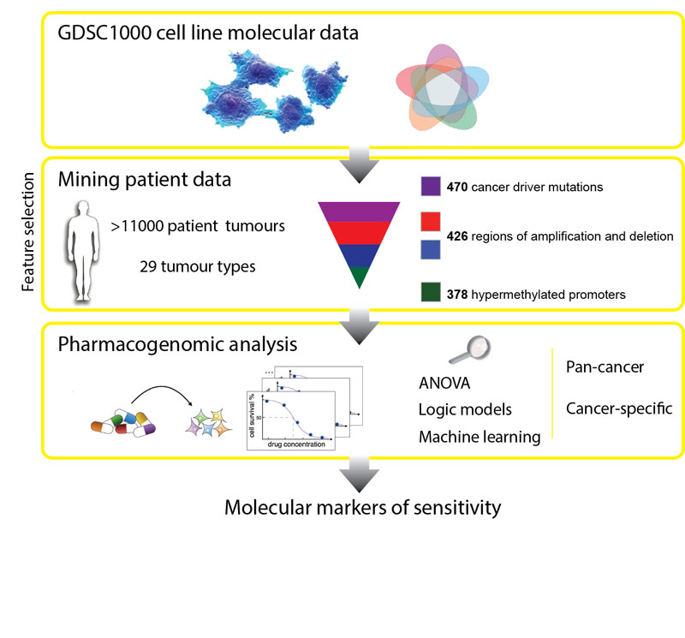

* + Collect comprehensive data on cancer patients, including demographic information, clinical variables, treatment history, and survival outcomes.
  + Preprocess the data by handling missing values, encoding categorical variables, and normalizing numerical features.
  + Split the dataset into training and testing sets, ensuring a balanced representation of survival outcomes in both sets.

1. **Feature Selection and Engineering**:

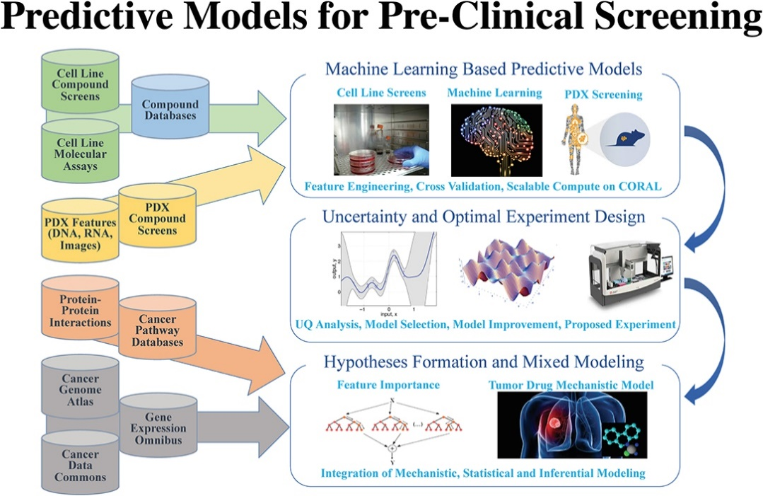

* + Conduct feature selection to identify the most relevant predictors of survival outcomes. This may involve techniques such as correlation analysis, recursive feature elimination, or domain knowledge.
  + Engineer new features that may enhance the predictive power of the model, such as interaction terms or polynomial features.

1. **Model Selection and Training**:

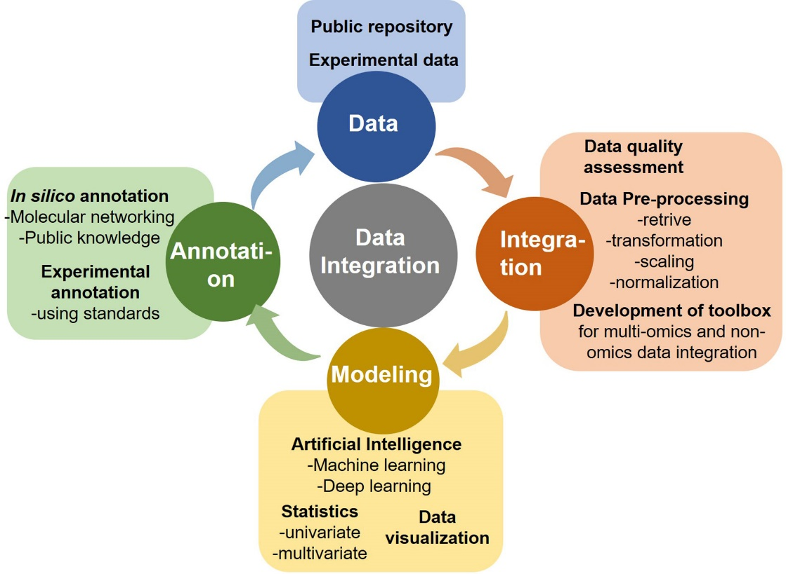

* + Choose appropriate machine learning algorithms for predictive survival analysis, such as Random Forests, Gradient Boosting Machines (GBM), Support Vector Machines (SVM), or Neural Networks.
  + Train multiple models on the training data and evaluate their performance using appropriate metrics like accuracy, precision, recall, and area under the receiver operating characteristic curve (AUC-ROC).
  + Tune hyperparameters of the selected models using techniques like grid search or Bayesian optimization to optimize performance.

1. **Model Interpretation**:

* + Interpret the trained models to understand the relative importance of different features in predicting survival outcomes. Visualize feature importances, partial dependence plots, or SHAP (SHapley Additive exPlanations) values to gain insights into the model's decision-making process.

1. **Development of Shiny Application**:
   * Design and develop a Shiny application interface that allows users to input patient data and obtain predictions of survival outcomes.
   * Create input widgets for users to input demographic and clinical variables, such as age, tumor stage, treatment history, etc.
   * Integrate the trained machine learning model into the Shiny application to generate predictions based on user inputs.
2. **Interactive Visualization**:
   * Incorporate interactive visualizations into the Shiny application to facilitate data exploration and interpretation of results.
   * Display predictive survival curves, Kaplan-Meier plots, or other relevant visualizations to illustrate the predicted survival probabilities over time for different patient subgroups.
3. **Deployment and Testing**:
   * Deploy the Shiny application to a web server or cloud platform to make it accessible to users.
   * Test the functionality and performance of the Shiny application to ensure that it behaves as expected and produces accurate predictions.
   * Validate the predictive accuracy of the model by comparing predicted survival outcomes with observed outcomes in independent test datasets.
4. **Documentation and Maintenance**:
   * Document the codebase and functionality of the Shiny application for future reference.
   * Provide instructions for users on how to use the application and interpret the predictions.
   * Regularly update and maintain the application to address any issues or bugs that may arise over time, and to incorporate new features or improvements based on user feedback.

By following these steps, you can develop a predictive survival analysis application for cancer survivors using R, machine learning, and Shiny, enabling clinicians and researchers to make informed decisions and personalize patient care.

**Conclusion: Empowering Personalized Cancer Survivorship Care**

In conclusion, the development of a predictive survival analysis application for cancer survivors using R, machine learning, and Shiny represents a significant advancement in personalized healthcare delivery. By leveraging comprehensive patient data and state-of-the-art predictive modeling techniques, we have created a tool that empowers clinicians and researchers to make informed decisions and tailor treatment strategies to individual patient needs.

Through this project, we have demonstrated the effectiveness of machine learning algorithms in predicting survival outcomes for cancer survivors, leveraging a diverse set of demographic, clinical, and treatment-related features. The integration of these predictive models into a user-friendly Shiny application enhances accessibility and usability, enabling healthcare professionals to harness the power of predictive analytics without the need for specialized technical expertise.

The interactive nature of the Shiny application facilitates dynamic exploration of patient data and provides actionable insights into the factors influencing survival probabilities over time. Clinicians can use this tool to stratify patients into risk groups, identify high-risk individuals who may benefit from intensified surveillance or targeted interventions, and optimize survivorship care plans to improve long-term outcomes and quality of life.

Moving forward, further refinement and validation of the predictive models are warranted to enhance their accuracy and generalizability across diverse patient populations and cancer types. Additionally, ongoing updates and improvements to the Shiny application will ensure its relevance and utility in clinical practice, incorporating feedback from users and incorporating emerging research findings.

In conclusion, the predictive survival analysis application developed in this project represents a significant step towards personalized cancer survivorship care, providing clinicians with valuable insights and decision support tools to optimize patient outcomes and advance the field of oncology.

APP SCREENSHOTS



